**Stamford University Bangladesh**

**Department of Computer Science & Engineering**



**Group name: Bit Legion**

**Online Mobile Shop**

**Software Engineering Sessional**

**CSI 332**

**Proposal**

**Submitted by:**

**Shekh Raisul Islam ID:CSE06307450**

**Tanjina Sharmin ID:CSE06307439**

**Md Juwel Islam ID:CSE06307460**

**Introduction:**

We already work in our proposal now we have discuss about our information gathering for the project.

**Objective of project:**

* The main objective of the project is to help the ongoing user help to attain an easy way to get mobile in online shop.
* It is basically a very instant processing system by which customer can get the mobile in the right condition.
* The manager of the mobile store also finds it sufficient enough to view the details of the sales, servicing and well organized way to employ the staff that are included in the mobile store itself.

**Information gathering system:**

We chosen three system for information gathering:

* Interview
* Questionnaires
* Investigation

**Interview: (Client)**

We use funnel type for interview system.

The interview questions and answers are given below:

**Question 1: Describe your business in a few sentence?**

Answer: Actually we have a mobile shop. We import different kind of smart phone from china. Now we want to increase our business by a online mobile shop.

**Question2: What specific features do u want?**

Answer: Different Categories for the people of different gender, age and classes for various products. Must have a built in customer support chat application for continuous care.

**Question3: What are your goals for this project?**

Answer: To generate more sell and achieve customer satisfaction.

**Question4: Who is your target audience?**

Answer: Basically young people aged between 18-35 from metropolitan area in preliminary stage.

**Questin5: Who are your main competitors ?**

Answer: Actually running e-commerce sites who sell mobile phones.

**Question6: What will make you different from your competitors?**

Answer: Easy to use and order product.

**Question7: What is your expected time frame for total project completion?**

Answer: 3 months

**Questionnaires: (Users)**

We collect the questionnaires result from the social media .

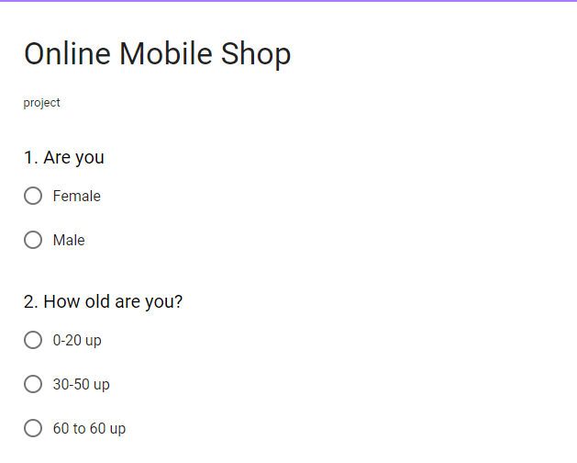

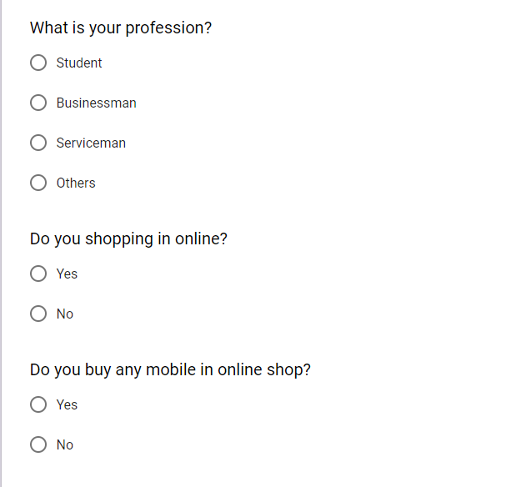

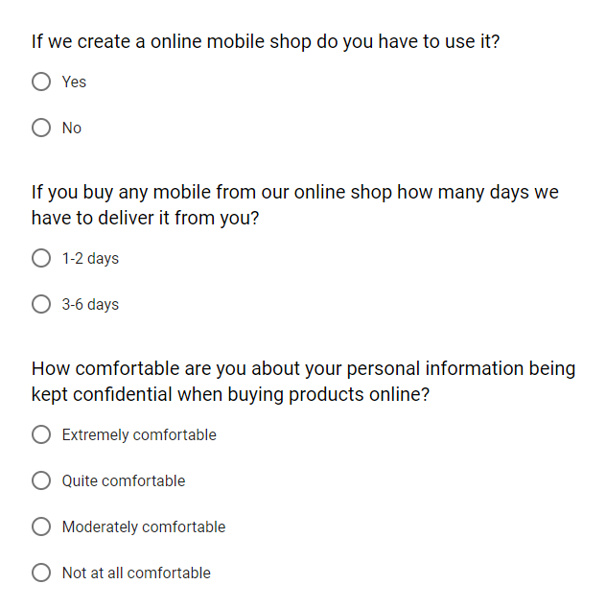

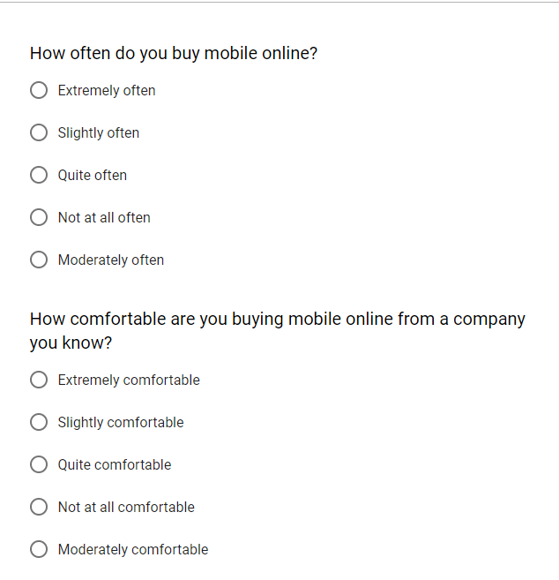

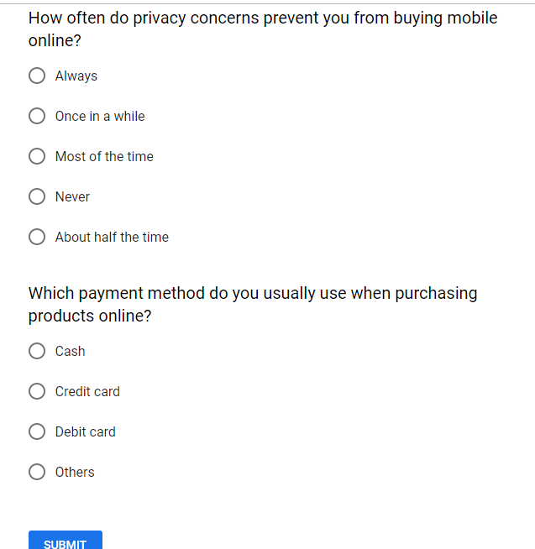

**Investigation:**

More than 140 million people, out of Bangladesh's population of 160 million, use mobile phones while around 80 million people access the internet, say the telecom regulators. According to current reports, at present 1.6 billion people use their mobile devices to shop online globally.

**Analysis:**

In our investigation, interview and questionnaires process we see that:

* Most of the people want to buy mobile phone from online mobile shop.
* Most of the people feel comfortable to buy mobile phone in online from a company they know.
* Most of the people like to payment in cash.
* Our client target is young generation in our analytics young generation is more inclined to buy mobile from online mobile shop.

**Conclusion:**

This report will make our project work easier. It also helps to make our web based software.

**Survey Result:**

